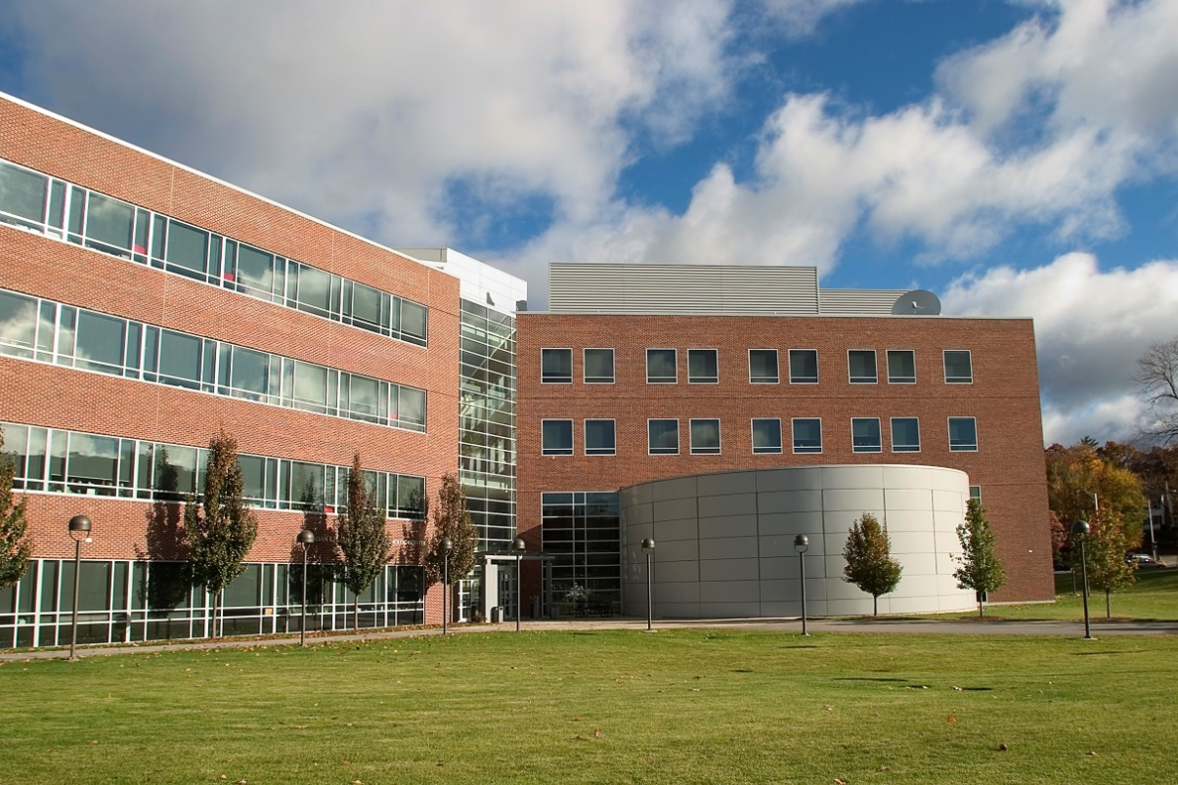

YOUR DEPARTMENT

Worcester State University

486 Chandler Street, Worcester, MA 01602  
508-929-8000

worcester.edu/department

name@worcester.edu

Place Call Out Text Here

Place Call Out Text Here

Place Call Out Text Here

Place Call Out Text Here

Place Call Out Text Here

Place Call Out Text Here

Place Call Out Text Here

# Article Title

This is where the article content appears

# Article Title

This is where the article content appears

# Article Title

This is where the article content appears

# Article Title

This is where the article content appears

# Article Title

This is where the article content appears

# Article Title

This is where the article content appears

# Article Title

This is where the article content appears

<Month> <Year>

WSU Newsletter